Ben Bode assignment 8.2

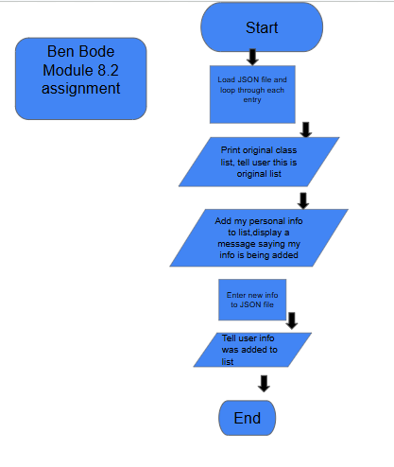

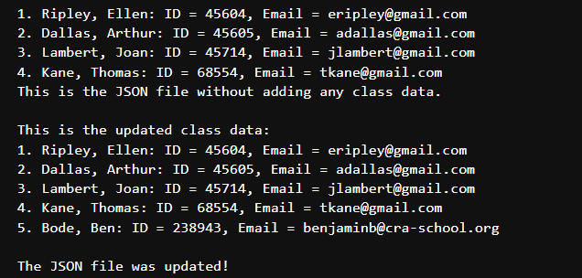

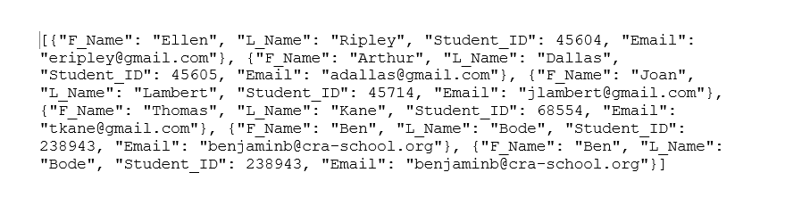
I ran the code a few times and never got the popup window, so I didn’t take a screenshot of it. I did not get it even when I deleted the student.json file and redownloaded it to change the file again. I might need to get my computer checked.

